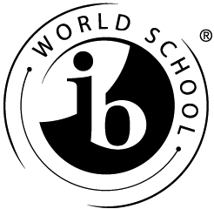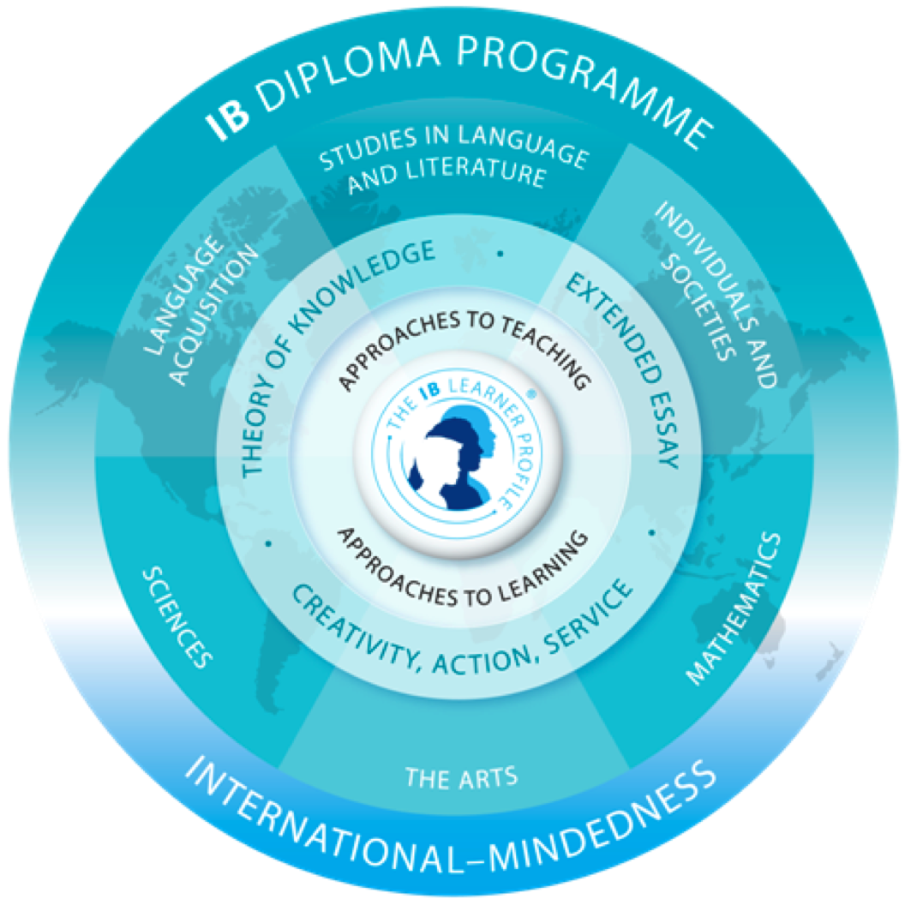 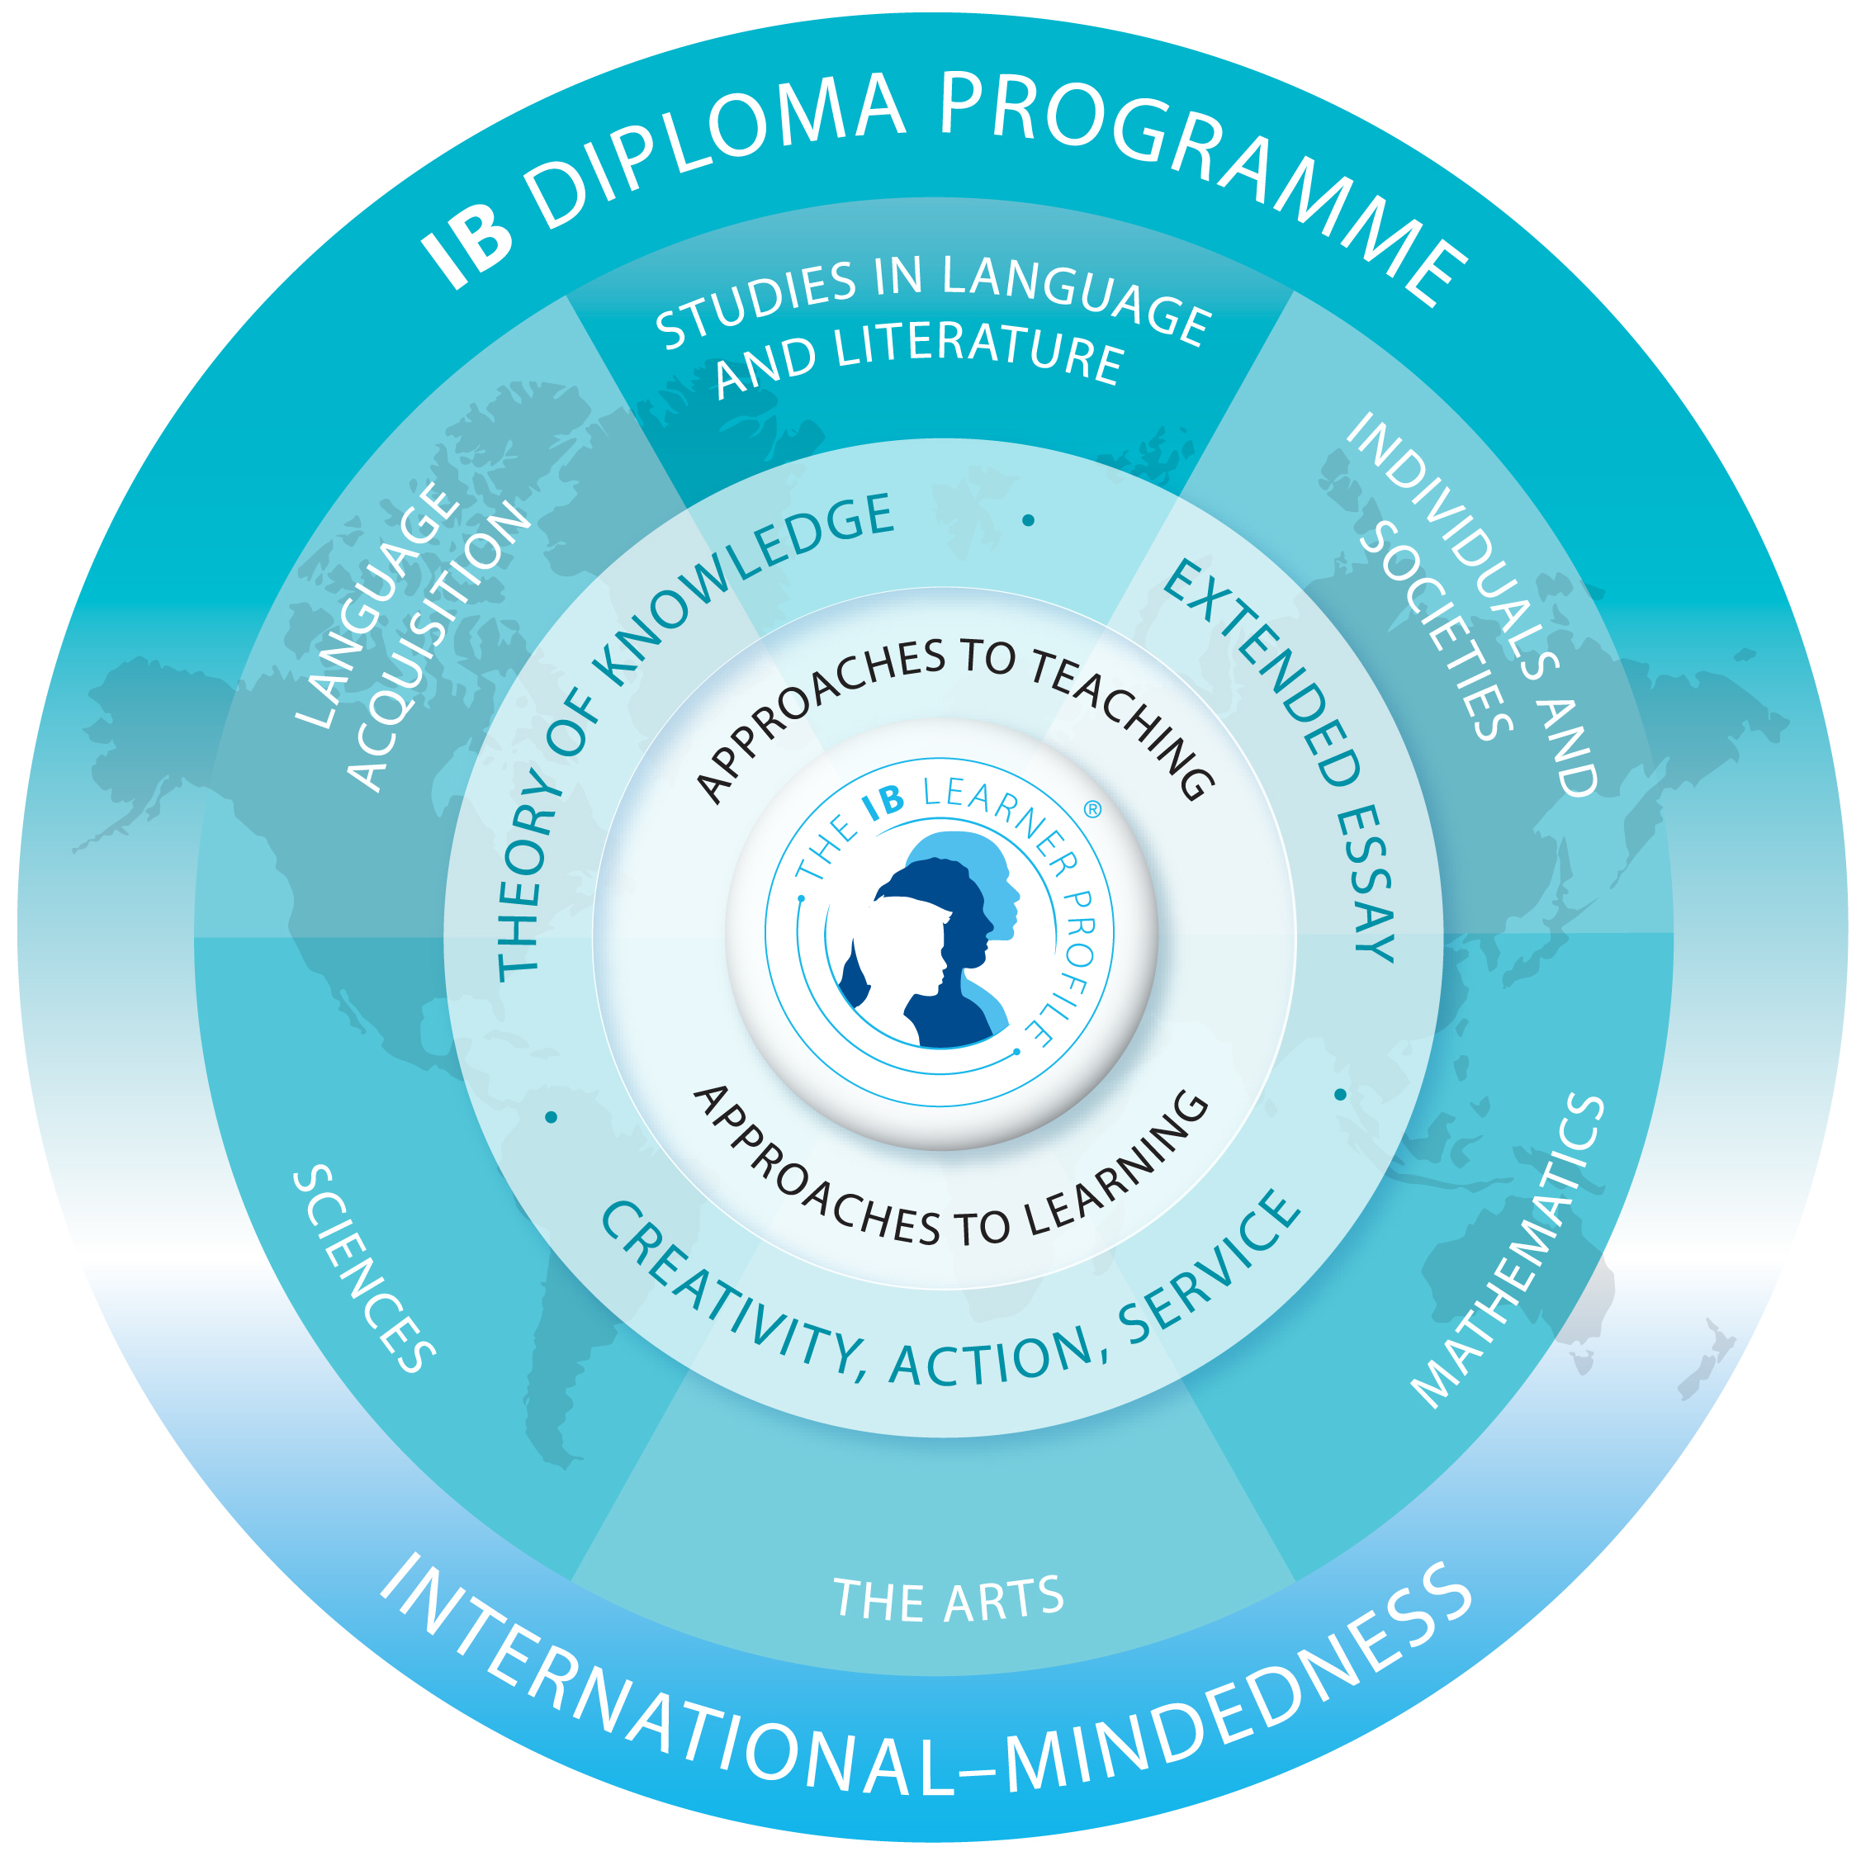

For more information contact:

IB Coordinator

Lo-Ellen Park Secondary School

275 Loach’s Road

Sudbury, Ontario

P3E 2P8

Phone: 705-522-232-

Fax: 705-522-8178

IB Graduates are World Class Scholars.

Lo-Ellen Park Secondary School has been offering the IB Diploma since 2001. We are authorized by the International Baccalaureate in Geneva, Switzwerland.

[**www.ibo.org**](http://www.ibo.org)

* In grades 9 and 10 students are prepared for entry into the IB Diploma
* IB Prep courses cover the Ontario curriculum and add enrichment and skill development in an accelerated learning environment
* Open to all students who have the commitment, ability and interest to pursue a more challenging academic pathway
* The IB Diploma begins in grade 11 and offers an international education in English, French, Math, Science, History and Visual Art.

## IB Preparatory Programme

[Street Address]   
[City], [State] [Postal Code]  
[Web Address]

International Baccalaureate Programme

Lo-Ellen Park Secondary School

***“The International Baccalaureate program, in my eyes, was a pivotal part of both my personal and academic development. It armed me with the skills I needed to face not only my post-secondary education, but many of life’s challenges. I can confidently say that I have absolutely no regrets in choosing to participate in the program, and I would not be the same person I am today without it.”* –Alex Berryman**

*Alex Berryman was a part of the graduating class of 2011-2012, where he served as Vice-President of the Student Council and was member of numerous clubs and societies. Alex is currently studying at Carleton University in Ottawa.*

**We are proud to acknowledge the Rainbow District School Board and Laurentian University’s J. N. Desmarais Library as sponsors/partners of the IB Programme.**

* An international curriculum that is taken over two years in grades 11 and 12
* A comprehensive pre-university course of study which is designed to meet the highest standards required by any secondary school student in the world
* A classroom experience that promotes collegiality, open-mindedness and personal growth
* Most universities grant advanced placement and first-year credits to IB diploma graduates
* In some cases, a full year of university standing is awarded
* Incremental scholarships based on diploma points are awarded by most universities
* Students who are committed to learning and who are interested in an academic challenge
* Self-motivated and disciplined learners who have achieved a minimum of an overall 80% in their academic subjects
* Those who are looking for an enriching learning environment
* Students who have demonstrated a strong commitment to learning and the discipline to succeed in a competitive world

What will I study in IB? Who Should Apply?

What are the benefits?

* A common, standardized curriculum recognized around the world for its high international standards
* An opportunity for mastery in a diversity of subjects
* A rigorous academic programme that cultivates critical thinking, research, and community involvement
* Balanced study in a variety of subjects which promotes international mindedness and mobility

*The IB Diploma is a symbol of academic integrity and intellectual promise.*

# What is IB?